[Mariska Hargitay, Chris Meloni On The 2022 Emmys Red Carpet (today.com)](https://www.today.com/popculture/awards/mariska-hargitay-chris-meloni-2022-emmys-red-carpet-rcna47314?cid=sm_npd_td_tw_ma)

Sept. 12, 2022, 8:01 PM -03 / Source: TODAY

By MC Suhocki

Before we watch [Mariska Hargitay and Chris Meloni](https://www.today.com/popculture/tv/mariska-hargitay-posts-new-pic-chris-meloni-law-order-set-rcna39869) slay the big screen Sept. 22 during [NBC’s historic “Law & Order” crossover premiere](https://www.today.com/popculture/tv/law-order-brings-3-casts-together-first-time-historic-crossover-rcna44435), we will be staring (respectfully) at these sizzling photos of the iconic duo melting the red carpet to shreds at [the 2022 Emmy Awards](https://www.today.com/popculture/awards/emmys-2022-winners-list-emmys-winners-rcna47153).

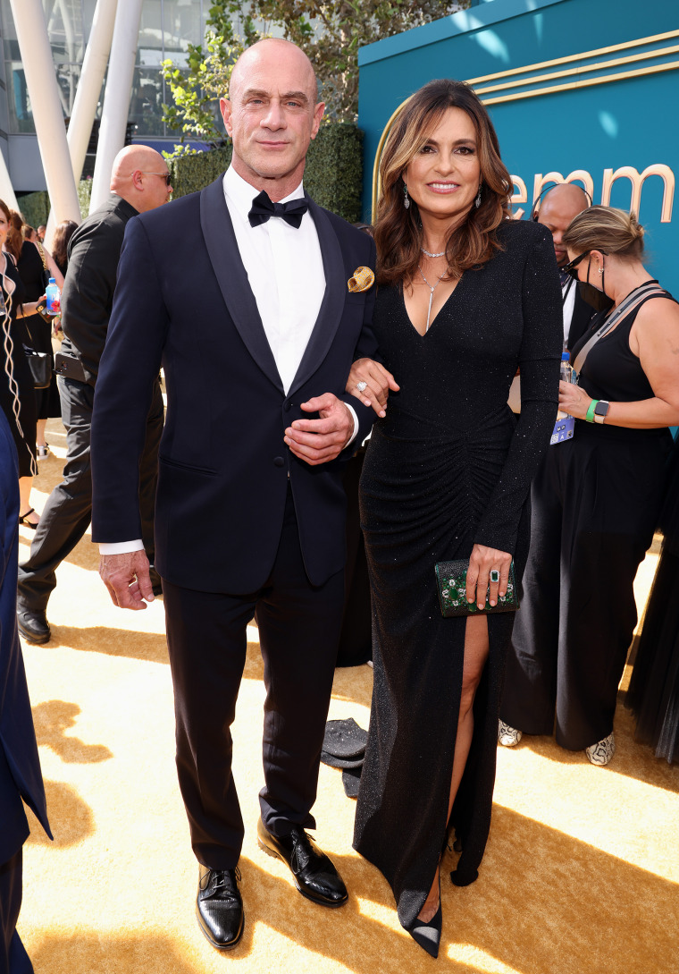They came to SLAY.Mark Von Holden/NBCUniversal / NBC via Getty Images

During an interview with E! on the red carpet, Meloni and Hargitay said they "never" get tired of working together after nearly 25 years.

"I love him, and I've never gotten sick of him," Hargitay said as Meloni embraced her.

They — Eric Jamison / AP

When asked if their "Law & Order" characters, [Capt. Olivia Benson and Detective Elliot Stabler](https://www.today.com/popculture/should-benson-stabler-date-debate-between-2-svu-experts-t217280), would ever get together, Hargitay and Meloni locked eyes and shared a smirk before turning away from each other and standing back to back.

"You want the tea, baby," Hargitay cracked. "Sweetheart, get in line!"

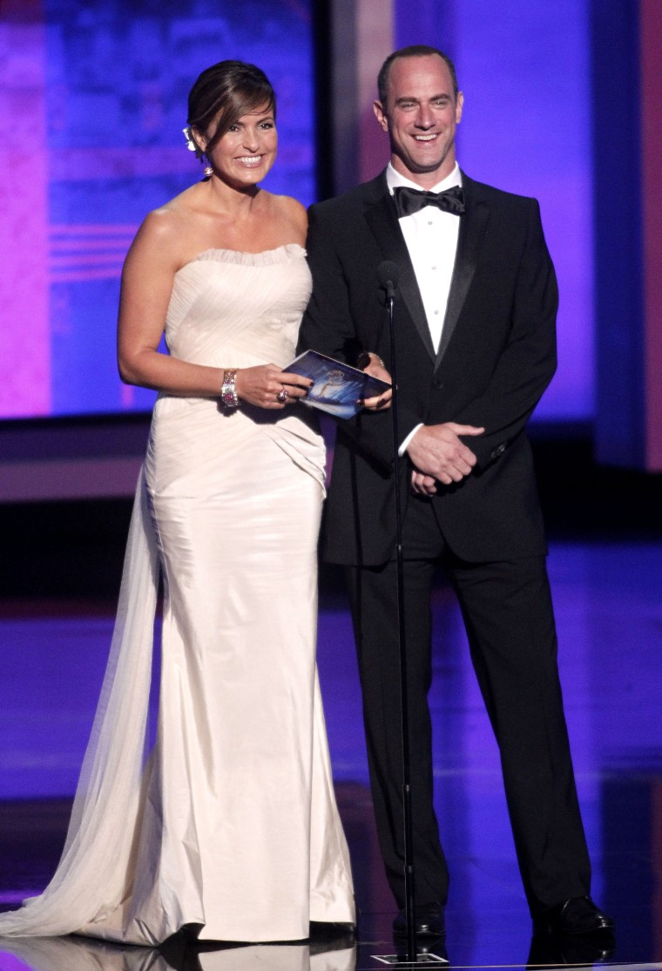Our favorite Emmy Award presenters in 2010.Jeff Kravitz / FilmMagic

Their joint attendance is especially sentimental because the last big award show Hargitay and Meloni attended together was the Emmys in 2010.

At the time, they presented the award for outstanding writing for a drama series, and Hargitay was also nominated for best leading actress in a drama series.

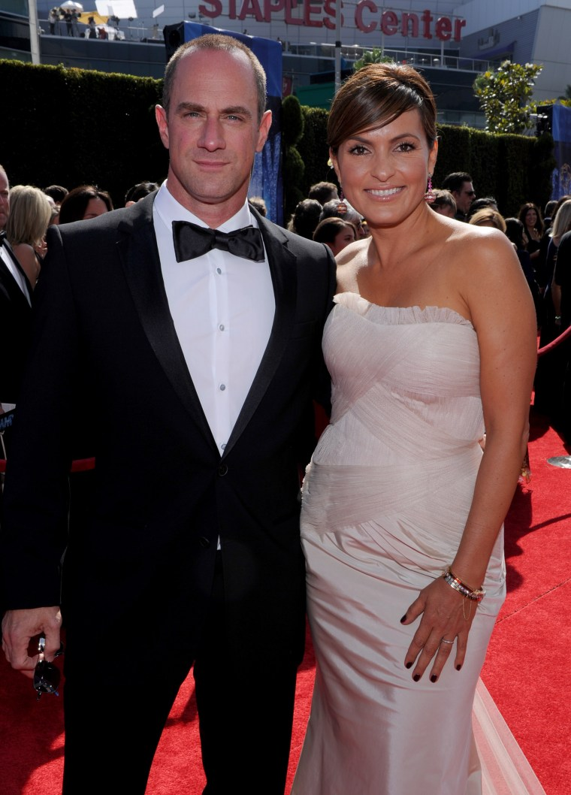Christopher Meloni and Mariska Hargitay at the 62nd Primetime Emmy Awards in 2010.Photo by Vince Bucci / NBCUniversal via Getty Images

The real winners that night were the fans watching all the action unfold at home, as the two walked hand in hand and [nearly kissed on the red carpet](https://www.youtube.com/watch?v=NEPY9QYjhgM).

Babies!Patrick McMullan / Patrick McMullan via Getty Image

Flash-forward 12 years to the 74th Primetime Emmy Awards, where [our favorite crime-fighting duo](https://www.today.com/popculture/tv/olivia-benson-elliot-stabler-relationship-timeline-law-and-order-svu-rcna37289) have ditched their police attire for glam get-ups.

Hargitay and Meloni are also again presenters Monday evening, along with Kelly Clarkson, Mindy Kaling, [Jeremy Allen White](https://www.today.com/popculture/tv/jeremy-allen-white-carmy-the-bear-thirst-tweets-rcna37874), Lizzo, ["Hacks" stars Jean Smart and Hannah Einbinder](https://www.today.com/popculture/popculture/hacks-star-hannah-einbinder-gives-speech-jean-smarts-walk-fame-event-rcna26047) [and more](https://www.today.com/popculture/awards/emmys-2022-nominees-host-date-time-channel-rcna37140).

Meloni teased fans before the red carpet when he responded to someone asking for a selfie on Twitter.

"YOU GOT IT," he tweeted along with a close-up shot of his and Hargitay's faces.

Thanks to [the return of Meloni’s Elliot Stabler on “Law & Order: Organized Crime”](https://www.today.com/popculture/tv/elliot-stablers-back-nearly-year-happening-benson-rcna19588) in April 2021, fans have been treated to seeing [more of him with Hargitay](https://www.today.com/popculture/tv/olivia-benson-elliot-stabler-relationship-timeline-law-and-order-svu-rcna37289), whose Capt. Olivia Benson is the longest-running female character in a prime-time live-action TV series.

The pair posted a photo together in February at the Super Bowl and also co-starred in [an ad with other NBC talent](https://www.today.com/popculture/tv/mariska-hargitay-chris-meloni-real-stars-super-bowl-rcna16127) that ran during the big game.

In November 2021, Glamour honored Hargitay as [one of their Women of the Year](https://www.today.com/popculture/mariska-hargitay-how-mom-jayne-mansfield-s-death-impacted-her-t237078), and Meloni presented his “fearless” longtime friend [with the honor](https://www.today.com/popculture/mariska-hargitay-s-pink-gown-was-tribute-mom-jayne-mansfield-t238172).

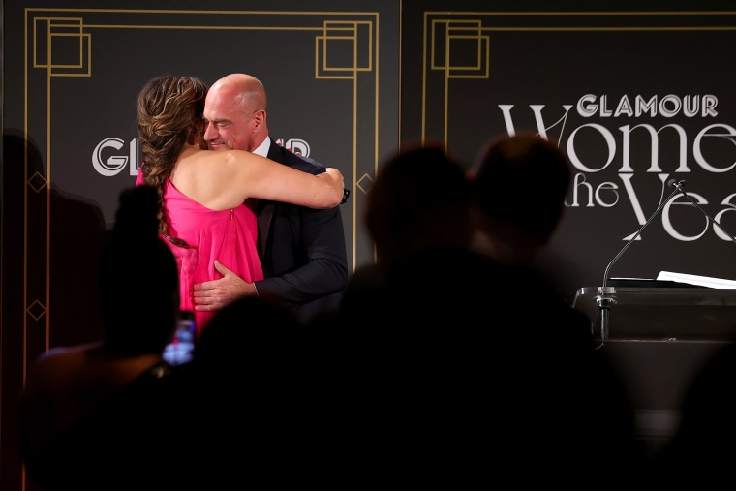Mariska Hargitay and Chris Meloni hug during Glamour Celebrates 2021 Women of the Year Awards.Cindy Ord / Getty Images for Glamour

[“Law & Order” fans](https://www.today.com/popculture/svu-fans-are-freaking-out-over-benson-stabler-moment-new-t239190) have also been enjoying all of [the behind-the-scenes photos of the actors filming together](https://www.today.com/popculture/tv/new-pics-mariska-hargitay-chris-meloni-filming-law-order-rcna24378) since Meloni came back to the franchise.

Meloni revealed the story behind the snaps showing him and Hargitay touching each other’s faces [during an interview with TODAY in May](https://www.today.com/popculture/tv/chris-meloni-story-law-order-set-pics-mariska-hargitay-rcna29078).

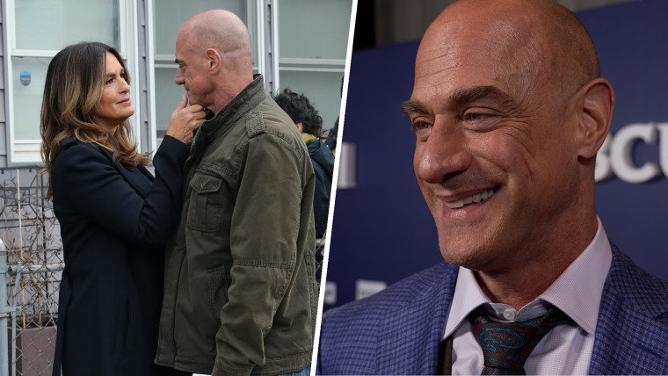

## [Chris Meloni reveals story behind ‘Law & Order’ set pics with Mariska Hargitay](https://www.today.com/video/chris-meloni-reveals-story-behind-law-order-set-pics-with-mariska-hargitay-140215365697)

MAY 17, 202203:35

He said they “used to do a schtick” where one of them would touch the other’s face and say, “You’re great kid.”

And in April, Hargitay sent all of her and Meloni’s fans into a spiral when [she shared a sultry snap from her bestie’s birthday party.](https://www.today.com/popculture/mariska-hargitay-chris-meloni-birthday-pic-rcna22807)

“Happy 61 @chris_meloni you’re aging like a fine wine cheers,” she wrote, along with a string of celebratory emoji and the hashtag #HesStillGotIt.

In March, the duo re-created the moment they met [during an appearance on “Late Night With Seth Meyers”](https://www.today.com/popculture/tv/mariska-hargitay-chris-meloni-re-create-moment-met-svu-audition-rcna21982) — hug and all.

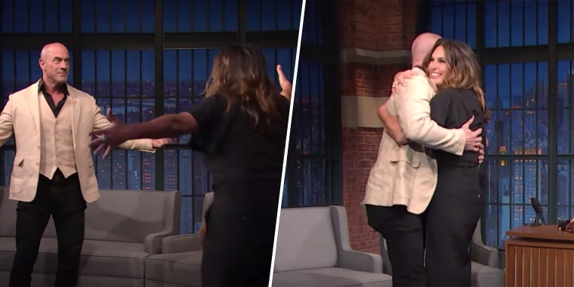Late Night with Seth Meyers/YouTube

They also shouted out their “crazy, crazy loyal” fans and highlighted their “beautiful” nicknames: Chriska, Marshmelon and Bensler.

These two are the gifts that keep on giving, and we hope they never stop.